**Q1.** Count the number of students in each course at the University. Print the course name, as well as the number of students.

SELECT C.name, count(*) AS studentnumber

FROM Student AS S, Course AS C

WHERE S.course = C.id

GROUP BY course;

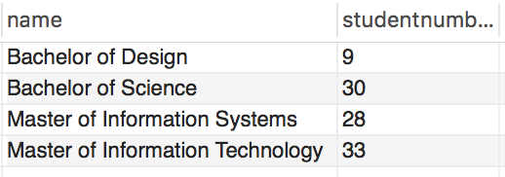

4 Rows

**Q2.** Is there any subject failed by more than one student? List the subject code as well as the number of failures.

SELECT concat(area, yearlevel, code) AS subjectcode, count(student) AS failurenumber

FROM StudentTakesSubject

WHERE result < 50

GROUP BY subjectcode

HAVING failurenumber > 1;

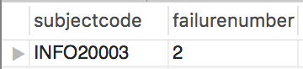

1 Row

**Q6.** For each student who has completed COMP10001 print their name, result and their academic grade (*H1*,*H2A* etc).

SELECT concat(S.firstname,' ', S.lastname) AS name, STS.result AS result,

CASE WHEN result >= 80 THEN 'H1'

WHEN result < 80 and result >= 75 THEN 'H2A'

WHEN result < 75 and result >= 70 THEN 'H2B'

WHEN result < 70 and result >= 65 THEN 'H3'

WHEN result < 65 and result >= 50 THEN 'Pass'

ELSE 'Fail' END AS academicgrade

FROM StudentTakesSubject as STS, Student as S

WHERE S.id = STS.student and concat(STS.area, STS.yearlevel, STS.code) = 'COMP10001';

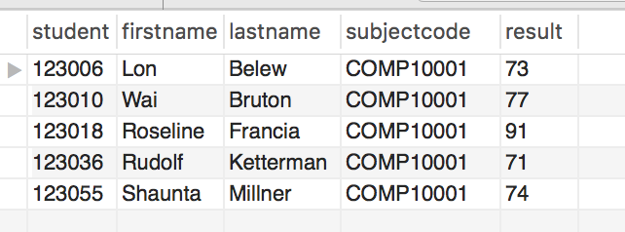

5 Rows

**Q8.** List the lecturers who teach across all study areas.

SELECT lecturer

FROM (SELECT DISTINCT lecturer, area FROM Subject) AS S

GROUP BY lecturer

HAVING count(lecturer) = (SELECT count(*) FROM StudyArea);

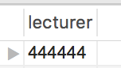

1 Row

**Q9.** Have any students from Gilberton suburb enrolled into Bachelor of Science course repeated a subject at undergraduate level?

SELECT STS.student

FROM StudentTakesSubject AS STS, Student AS S, Suburb AS SB, Course AS C

WHERE STS.yearlevel < 9 AND STS.student = S.id AND C.name = 'Bachelor of Science'

AND C.id = S.course AND SB.name = 'Gilberton' AND SB.postcode = S.postcode

GROUP BY STS.student

HAVING count(*) > count(distinct STS.area, STS.yearlevel, STS.code);

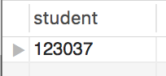

1 Row

**Q10.** The Dean has asked you to design a table that will record the student evaluations for each lecturer for each subject he has taught in each academic semester. You are to write the DDL to create the table including all suitable attributes and write the references to the Foreign Keys.